Project 3 | Double Linked Lists

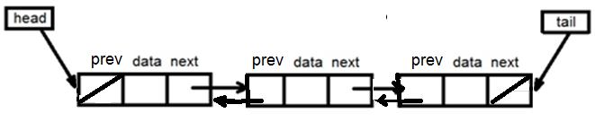

For this project, you will need to implement –
- A generic double singly-linked list (class) with an iterator
- A generic sorted double single-linked list (class) with an iterator
  - This class must inherit from the specified generic double single-linked class
- Check out the following URL for additional information
  - https://www.geeksforgeeks.org/difference-between-singly-linked-list-and-doubly-linked-list/#:~:text=%20%20%20%20Singly%20linked%20list%20%28SLL%29,%20%20More%20efficient%20access%20to%20elements.%20

Academic Honesty Policy – Do your own work. Each project submission will be compared against other submissions from current and previous semesters.

Good Faith Attempt (GFA) Requirement – Your submission must successfully pass all of the provided (public) Junit test cases. In general, they are the xyz_test.java and xyz_GFA_test.java files (where xyz is the project name).
Expectations
- INCLUDE your name as the author on every Java file that you are creating
- The book provided bits and pieces of code for a (singly) linked list. You might want to follow the book and implement it first, and then enhance it to become a doubly linked list

Specifications

BasicDoubleLinkedList

This generic double single-linked list relies on a head (reference to first element of the list) and tail (reference to the last element of the list). Both the head and the tail are set to null when the list is empty.

Both the head and tail point to the same element when there is only one element in the list. Each node structure of the list has three fields: data and the prev and next references.

The class must only define the following entities –
- An inner class Node
- An inner class that implements ListIterator (for the iterator method)
- Head and tail references
- An integer representing the list size.

For the ListIterator, only the next(), hasNext(), previous() and hasPrevious() methods are required. All other methods can throw the UnsupportedOperationException, such as:

public void remove() throws UnsupportedOperationException{
throw new UnsupportedOperationException();}

To make your life easier, all entities are defined as protected so they can be accessed by the subclass. Review the provided Javadoc for more information.

SortedDoubleLinkedList
A generic sorted double linked list extends BasicDoubleLinkedList class. It uses a provided Comparator to sort the list.

The addToFront and the addToEnd methods will not be supported. The add method is used to insert data to the list in sorted order.

Exception Handling
- UnsupportedOperationException – Use this Standard Java Library exception for the addtoFront and addToEnd methods (SortedLinkedList class) and by the remove method of the iterator
- NoSuchElementException – Use this Standard Java Library exception for the next method (Iterator class) when there are no more elements in the linked list.

GUI
A GUI driver has been provided to help you visualize your lists. Here is the minimum that must be in place in order to utilize the GUI effectively.
- The addToFront or addToEnd method of the BasicDoubleLinkedList must be implemented to create a basic doubly-linked list
- The add method of the SortedDoubleLinkedList must be implemented to create a sorted doubly-linked list
- The toArrayList method in both the BasicDoubleLinkedList and SortedDoubleLinkedList, which returns an arraylist of the items in the list from the head of list to the tail of list. This method is used to display the contents of the lists
- UI interprets all input as strings. Integer values won’t be sorted correctly

Testing and Student JUnit Test Cases
- Test cases and test results (See Project Rubric)
- Test your project with 4 other test cases that you have created. You need to ensure that your project is working correctly
- Capture your test runs (actual vs. expected results) in your write-up. It’s to demonstrate that that you have attempted to test your project. A 28% deduction will be imposed to any project that did not capture their test cases and respective test results in the write-up
- In addition, your submission will be tested against an additional set of private test cases
- Testing is very important
- You should not need to modify any of the provided Java files other than the referenced package names, such as package abc. Confirm with your instructor first, if you feel like a change is needed

Programming Concepts

This project utilizes the following concepts:
- Exception handling
- Generic classes
- Doubly linked List
- Ordered doubly linked List
- Iterators
- Comparators
Write-up & Submission Requirements
Review the provided rubric to understand the project expectations, including documentation, CMSC204 and programming requirements. Each project submission MUST include your working Java code and a write-up. For Project 1, a sample write-up has been provided.

Your write-up, at a minimum, needs to address -
- Approach, design & algorithm
  - DO NOT start coding your project immediately! Come up with a high level design first. Complete this step first, then write your code
    - Break the project into smallest modules where applicable
  - Each student is welcome to expand on the design. If your project includes “above and beyond” features, clearly articulate them in your write-up. Potential extra credit could be earned if that is the case
- Test plan & test cases
  - What test cases did you run?
  - I want to understanding your “thinking,” and you need to be sure that your project works!
  - For each test case, specify the expected vs. actual outputs
  - Capture several test runs as screenshots, as you run your test cases
  - I will attempt to break your code (with reasonable test cases)
- Highlight your learning experience and lessons learned
  - I am very interested to learn about what you have done, how you did, etc.
- Discuss your additional enhancement
  - What did you do?
- Any assumptions that you are making for this project
- Anything else that you want to share

Each student must submit one compressed (.zip) file back to the Assignment (link) with the following:
- Source code (.java files)
- Write-up (a Word or PDF file)
- Name your compressed file as <lastname>_project_x
  - where x is the project number and your last name (e.g., Thai_Project_1.zip)
- Review provided instructions on how to submit the project carefully (don’t assume anything)
- I can only grade what’s being submitted. Double check your submission
- I MUST BE able to compile, run and test every submitted project on my computer using a set of test cases. Just as important, I will READ your write-up first

Not clear? That’s okay, but do ask your questions. “I did not know” or “I did not understand” is not good enough.

Start working on each project immediately so that we can discuss any concerns or questions you have.

Sample Test Cases & Outputs (Consider them as examples only)

These are sample test runs only. They are provided to enhance your “understanding” of the project. Your actual runs may be different. Think about potential private test cases.

Adding to a Basic List Adding to a Sorted List
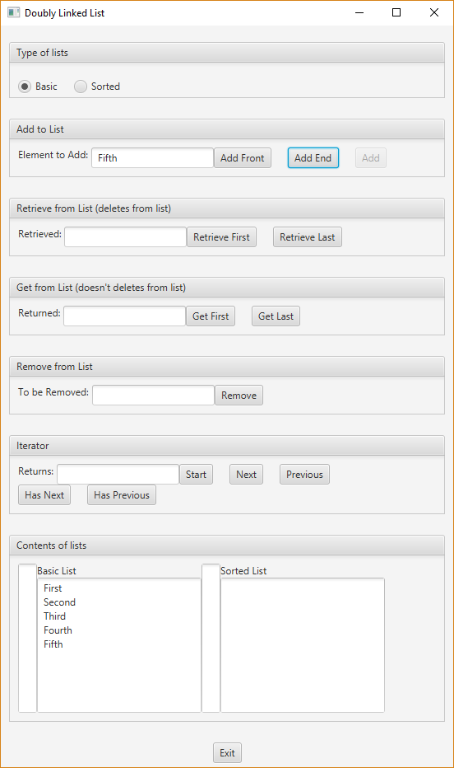
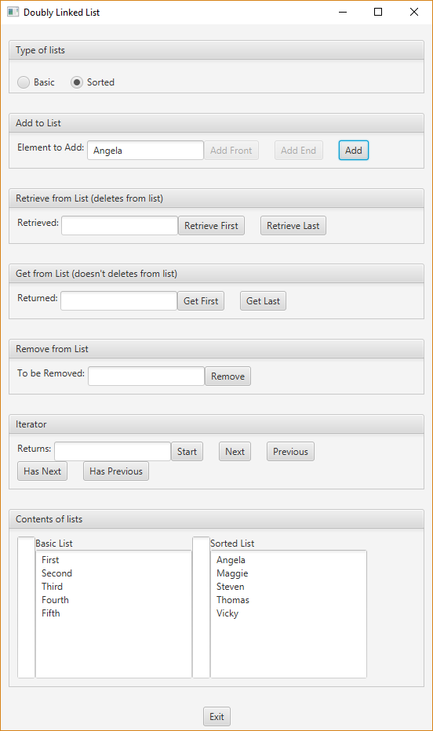

Removing Second from basic Removing Thomas from sorted
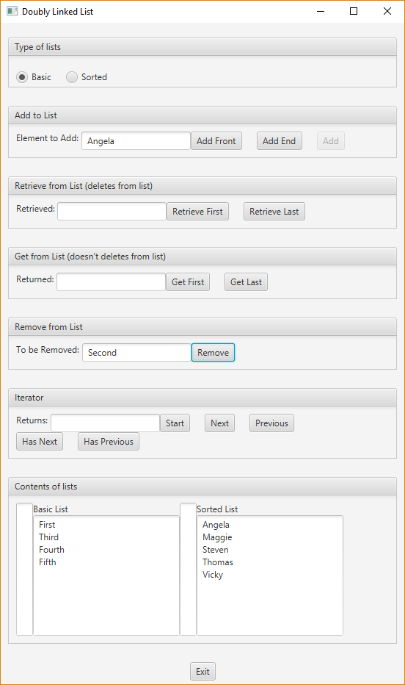
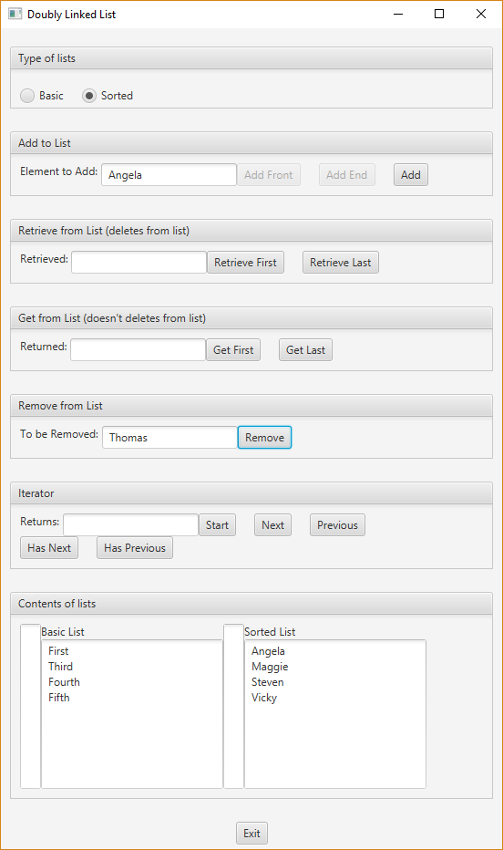

Start the iterators for Basic and Sorted. Think of iterators being “in between” nodes.

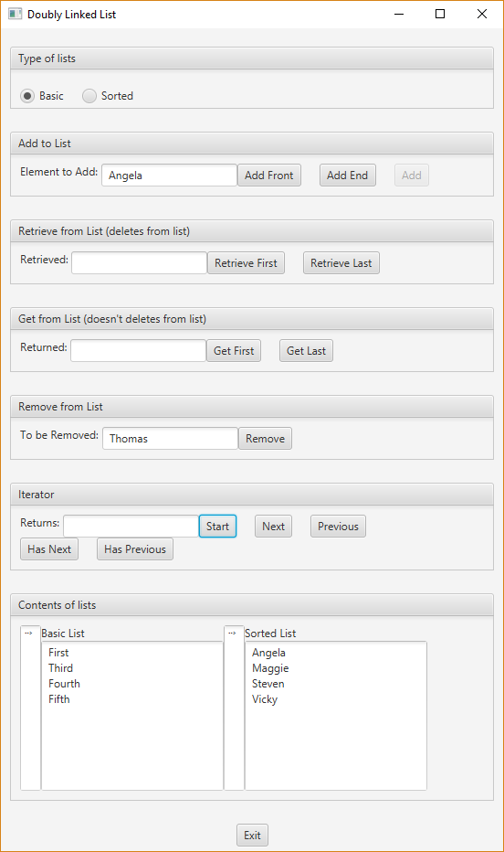

Example of selecting “Next” for Basic and then for Sorted list. Think of iterators being “in between” nodes.
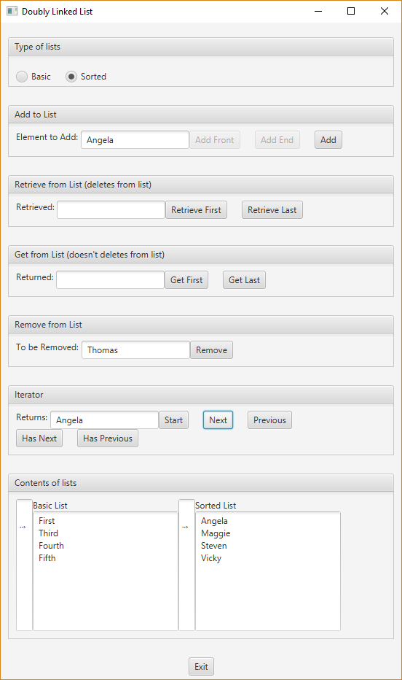
Example of “Next” for basic and “Previous” for Sorted. Think of iterators being “in between” nodes.
